2024 Summer Camp **Intern**

The Frazier Museum offers seven weeks of summer camps in June and July, serving children between the ages of 6-12. Our camps focus on fun and community building, and incorporate free time, free play principals, engaging history presentations, art activities, and hands-on projects. This year’s camp themes include History Through the Arts, Zines & Comics Camp, Camp Epic Fails (about historic failures, flops, and phonies), Ohio River history, and Camp Takeover (an exciting behind-the-scenes look at public engagement).

The Summer Camp Intern will assist with the development, preparation, and teaching of summer camp. The museum is looking for 2-3 people to serve in this position for two or more weeks each.

**Essential Functions**

* Support Frazier staff and Lead Teachers
  + Research eras/themes covered in camps
  + Contribute to the development and of age- and theme-appropriate camp activities
  + Plan and present 1-2 activities per week
* Leading children through day-to-day schedules and transitions

**Qualifications**

* Open to college sophomores, juniors, seniors, recent graduates or graduate students
* Open to students pursuing a degree in education, history, or liberal arts (Other degrees may apply, but please specify how this internship relates to your degree or career goals)
* Interns will work 37.5 hours per week, 8:30am-4:00pm Monday thru Friday
* Enthusiasm, patience, and a strong interest in working with children
* Willingness to be open and respectful of people from all backgrounds
* Must have strong written, oral, and interpersonal skills
* Must have the ability to multitask
* Must pass a background check

**Length of Internship**

* Two or more weeks, between late May – late July, 2024

**Additional Information**

* Free parking is provided
* College credit may be available
* Paid Teaching Assistant positions may be available – please inquire if you are interested

**How to Apply**

Email your resume and cover letter to education@fraziermuseum.org. For more information contact Zach Bramel, manager of youth and family programs, at [zbramel@fraziermuseum.org](mailto:zbramel@fraziermuseum.org).

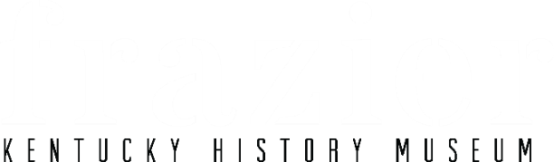

*Where the world meets Kentucky.*